# Seminar 2: Recognitions

Recognitions:

* Od recognises Ithaca
* Athena recognises Od
* Eurycleia vs. Telemachus:
  + Shared history vs. strangers (son never seeing his father before)
  + Telemachus as an important character can be targeted by the gods and is sceptic at first
  + Belief of paternity has an element of trust

# Seminar 3: Gods of Hesiod and Homer

*Works and Days:*

* Representation:
  + 13: The two Strifes represented as personifications of abstract concepts: the good and the bad (conflict)
    - The good Strife incentivises work
  + 47: Zeus and Prometheus as roles in a moral story: pain and toil are necessary elements of human condition in iron age; to try to escape them is to renounce the gods and deserve punishment
  + 98: “by the providence of Zeus”. 120: “by great Zeus’ design”. Worshipping Zeus as the lord of not only the skies, but the whole universe, where everything is done by his plan and cannot be changed
  + 239: Zeus the punisher, giver of retribution: wicked deeds by anyone and everyone will be punished
  + 393: “Demeter’s works”: although humans must work to bring in cereals, the final decision whether they acquire them is Demeter’s => **gods have final say in the lives of humans**
    - 474: “should Olympian Zeus himself grant a successful outcome later”
    - 666: “You are not likely to smash your ship, nor the sea to destroy the crew, unless it be that of set mind Poseidon the earth-shaker or Zeus king of the immortals wants to destroy them, **for in their hands lies the outcome of good and bad things alike**.”
  + 507: “when the North Wind [Boreas] blows”: personification used more as a literary device or just a reference instead of in a larger context (divine plan or some such thing)
  + 763: “No rumour ever dies that many folk rumour. **She too is somehow a goddess**.”: Abstract concepts personified as gods to give them more of a powerful meaning. A female negative goddess possibly because of Hesiod and/or society’s misogyny.
* Values:
  + 13: Competitiveness
  + 47: Work
  + Sacrifice to gods
  + Injustice must be punished
  + 146: Peace

*Theogony*:

* Representation:
  + 81: “Whomsoever great Zeus’ daughters [Muses] favour among the kings that Zeus fosters”: gods have final say in the successes of human life
  + 219: “the mercilessly punishing Furies who prosecute the transgression of men and gods”: Furies as a manifestation of karma, paying everyone their due
* Values
  + Justice (from chaos of the Titans to the order of the pantheon): Zeus marrying Themis (Right)

*Odyssey*:

* Representation:
  + Gods with questionable morality (Poseidon destroying Phaeacian ship)
  + The world of gods not in perfect unity, strife between gods (Athena deceiving Poseidon and acting without his presence/permission)
  + Everyone invested in human affairs
  + Overall: gods on more equal ground with humans
* Values:
  + Cunningness
  + Persuasiveness

Hesiod:

* Ambiguous morality
* Big picture, abstract
* Distance between gods and men
* Gods as embodiments
* Aetiology: origin, cause of the way things are

Homer:

* Glorifying gods
* Individuals with conflicting interests
  + Characters
* Direct, real, anthropomorphic, intimate connection

# Seminar 4: Images, Vessels, and Viewers

## 1. Jason and the Dragon

**We start with the single image of Jason and the Dragon drawn by the painter Douris. Look at the detailed image on Moodle.**

**How is the image designed?**

Circular, pattern around two asymmetrical figures

Tondo (circular design)

Split in the middle, two levels

**What aspects are emphasised by the design?**

Size of the serpent (because of the small canvas)

**What aspects are de-emphasised?**

**How can we identify the story?**

A fleece on a tree, serpent/dragon, IASON next to his head

Athena: owl, Aegis

**Is the round shape significant?**

Yes: it’s part of the cup, it reveals itself all at the same time because of the shape of the cup

**This exercise will be easier if you print out the image and draw the major divisions and contours on it. Remember: description is not neutral!**

## 2. Inside and Outside

**Look at the other images of this cup on Moodle.**

**Where are they located on the vessel?**

On the outside edge

**What do they show?**

Mostly men, some women, standing around in himation/chitons and talking(?), walking sticks by their sides

Men with beards looking at younger men

**How do they relate to the image of Jason and the Dragon?**

Argonauts?

Symposium retelling the story of The Quest for the Golden Fleece, common knowledge, bonding

## 3. Other Cups, Other Games?

**Look at the images of the other cups on Moodle.**

**What do these cups show?**

**How do the images on each cup relate to each other?**

Telling stories, entertainment

**How do these cups compare to the cup with Jason and the Dragon?**

More warlike

**How do these cups relate to viewers?**

Could be relatable to hoplites

**How do these cups relate to their contexts?**

**Are the labels significant and, if so, why?**

# Seminar 5: Alcaeus and Politics in Lesbos

**Strabo:**

**Mytilene has produced famous men: in early times, Pittacus, one of the Seven Wise Men; and the poet Alcaeus, and his brother Antimenidas, who, according to Alcaeus, won a great struggle when fighting on the side of the Babylonians, and rescued them from their toils by killing “a warrior, the royal wrestler” (as he says), “who was but one short of five cubits in height.” And along with these flourished also Sappho, a marvellous woman; for in all the time of which we have record I do not know of the appearance of any woman who could rival Sappho, even in a slight degree, in the matter of poetry. The city was in those times ruled over by several tyrants because of the dissensions among the inhabitants; and these dissensions are the subject of the Stasiotic poems, as they are called, of Alcaeus. And also Pittacus was one of the tyrants. Now Alcaeus would rail alike at both Pittacus and the rest, Myrsilus and Melanchrus and the Cleanactidae and certain others, though even he himself was not innocent of revolutionary attempts; but even Pittacus himself used monarchy for the overthrow of the oligarchs, and then, after overthrowing them, restored the city its independence.**

**Where are Lesbos and Mytilene? What happened there in politics during the seventh and sixth**

**centuries BC? Which sources give us accounts of these events?**

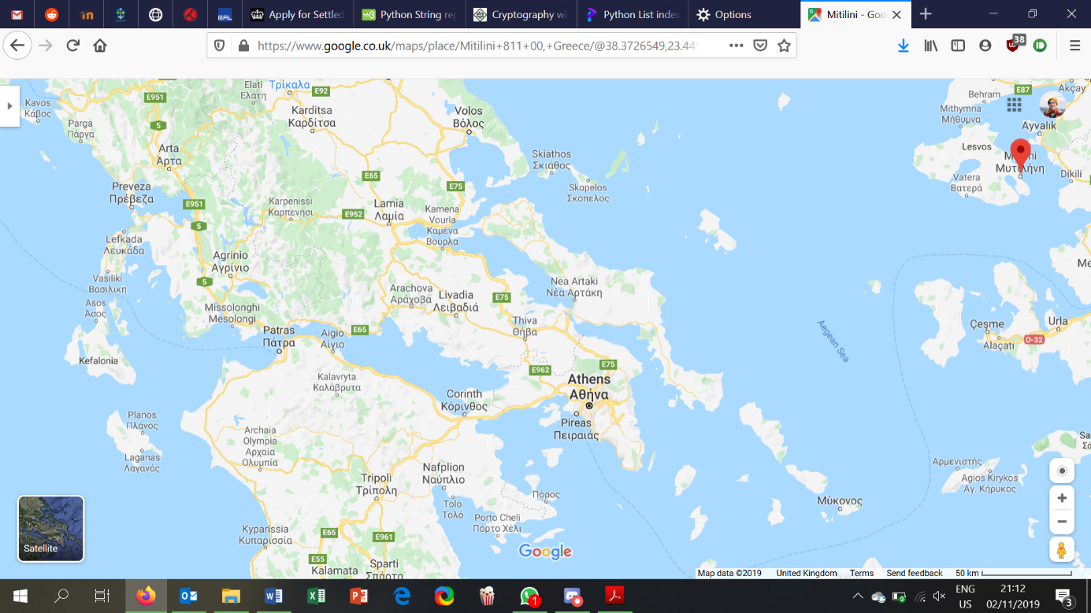

Alcaeus:

* Tyranny in Mytilene: Melanchrus, Myrsilus, Pittacus
* Pittacus as an awful tyrant

Aristotle:

* Pittacus was an elected tyrant (*aisymnetes*), widely held to have resigned his position once he had sorted his pol situation out

Mytilene:

* Factional infighting, Stasiotic (factional) poetry
* Succession of tyrants (Melanchrus $⇒$ Myrsilus $⇒$ Pittacus)

Sources:

* Other writers (quoting the original)
* Papyrus

**Whom does Alcaeus address with his poems?**

(Pittacus, Myrsilus,); Hera, Zeus and Dionysus; symposium/his group.

**What do you think was Alcaeus’ purpose in composing these poems? What are the advantages of**

**poetry for his objectives?**

Purpose:

* Increase political activity in council and assembly
* “Lament the follies of the community in allowing Pittacus power” – Osborne
* Bring down Pittacus
  + No honour
    - “jump on Pittacus from behind”
  + Pittacus broke his oath of not betraying members of “our company”
* Express his grievances about being in exile
  + Compares his life to a wolf
    - Bestial, feral
* Strengthen factional bond (with his company at the symposium)

Advantages:

* Widely available
* Speaks to the audience emotionally, inspires them
* Being able to compose and recite poetry is a sign of education, intelligence
  + *Paideia* – education, culture

**Compare Alcaeus’ image of Pittacus and the text passage from Strabo. How would you explain the**

**differences?**

Strabo is factual, although paints Pittacus in positive light at the end (the independence), while Alcaeus tries to motivate the people to revolt against Pittacus by describing him negatively (pot-bellied, etc)

**What are the advantages and disadvantages of Alcaeus’ poems for the modern reader in**

**understanding Mytilenean politics?**

Disadvantages:

* Very personal, not a general description of the whole community’s mindset
  + Biased towards his faction
* Later historians interested not in politics, but other topics like geography, philosophy, etc

Advantages:

* Gives insight into what people wanted to read about the political state: the entertainment value of it, or longing for change

# Seminar 6: The Siphnian Treasury at Delphi

Delphi:

* Sanctuary to Apollo
* Oracle
  + Political role
* Panhellenic (all polis) site

Frontal chariot?

Treasury:

* Marble
  + From Siphnos, Paros, Naxos
* Offerings to Apollo

## 1. The East Frieze

**How is the east frieze designed?**

On top of treasury, continuous (Ionic order)

Zeus with other Olympian gods weighing the souls of Achilles and Memnon, who are fighting on the right above a dead Antilochus. Achilles is with his Gorgon shield on display.

Memnon: Ethiopian warrior on the Trojan side who killed Antilochus (who sacrificed himself to save Nestor)

**What aspects are emphasised? What aspects are de-emphasised?**

Emphasised:

* The shield of Achilles
* Chaos of war
* Symmetry: humans likened to gods

De-emphasised:

**How do the figures and the design relate to the space of the building?**

It is at the top, but also the closest to the ground (closest to human view)

**What is going on in the frieze? How can we identify the story? Do you recognise any of the divinities?**

Zeus with other Olympian gods weighing the souls of Achilles and Memnon, who are fighting on the right above a dead Antilochus. Achilles is with his Gorgon shield on display.

Identify story by labels.

Divinities: Zeus, Hera, Athena, Ares, Poseidon

## 2. The East Side of The Building

**How does the frieze relate to the rest of the east side of the building?**

**When and how would visitors have seen this side of the building?**

When entering the sanctuary, first thing they notice of the treasury

## 3. Images and the Treasury

**What other sculpture was used on the treasury?**

North: Battle of the gods and Giants (Gigantomachy)

* Giants carrying hoplons (hoplite shields)

Front (West): Caryatids, chariots, Apollo(?)

**What does it show and where is it located? How are the images designed? Are they all the same stylistically (look especially at the horses on the east and south sides)? Is the style significant and, if so, why?**

**Are the images related to each other?**

**Does the design of the building and its architectural sculptures provide any insight into the potential motivations for building this construction?**

Display wealth.

## 4. Treasury and Sanctuary

**What is important about the choice of location for the building? How would visitors have encountered the treasury and its sculptures?**

North frieze continuous: experienced fully by walking by

West frieze static: experienced by walking closer and examining, enticing in

**Why might these sculptural themes have been chosen?**

Humans likened to gods with their wealth.

**Are the subjects significant in the context of this particular sanctuary?**

Apollo might have been depicted in front, and it is his sanctuary.

**Why do you think the Siphnians built this treasury?**

To display their wealth (from the gold and silver mines (Herodotus))

# Seminar 7: Herodotus and Croesus

**What is Herodotus's main subject in 1.1-94?**

Persia, Cyrus the Great (c. 557-530 BC), Croesus of Lydia

Croesus tries to conquer Persia, they win.

Lydians aren’t Greeks

**At what point does he start and why?**

6th c.? Phoenicians and Greeks interchanging women

His purpose and goal is the truth, not mythology.

**Draw a timeline for 1.5-28 and map the story against the timeline. What characterizes Herodotus’ narrative structure?**

Characterisation:

* Digressions
* Argumentative, assertive tone (*ethos* of travelling)
* Eye-witnesses

**What do you think is or are Herodotus' main source(s) for the story of Croesus?**

Oral: Delphians, Milesians, Corinthians, Lesbians,

Archaeological evidence: Taenarum (24), Delphi (14)

**Which parts of the Croesus sections do you think the most historically reliable and which do you**

**doubt the most?**

Doubtful:

* Solon meeting Croesus

Reliable:

* Bare minimum
* There was a king named Croesus

*The Histories* is a collection of stories with moral/ethnographical purpose

**What do you think was Herodotus’ purpose in writing down his “inquiry”?**

Preserve history:

“The purpose is to prevent the traces of human events from being erased by time, and to preserve the fame of the important and remarkable achievements produced by both Greeks and non-Greeks” (Herodotus, p. 3)

Morality: Solon (happiness

Ethnography: Gyges (nudity)

Oracle, religion, theology

# Last Seminar: The Colonisation of Cyrene

## 1. Cyrene

**Where are Thera and Cyrene? When was the settlement at Cyrene founded?**

Thera is in the island of Santorini, southern centre of the archipelago.

Cyrene (near present Shahhat) is in the northern coast of Libya.

631 BC?

## 2. Herodotus

**a. Whom does Herodotus' identify as his main sources for the story of the colonization of Cyrene?**

The Therans and the Cyreneans.

**Are there any other important sources that can be identified from his narrative?**

H.’s personal experience: seeing Colaeus’ dedication in the temple of Hera at Samos

**How do the accounts of his main sources compare? Are the accounts broadly consistent or contradictory?**

Broadly consistent, founder’s name and genealogy different.

**b. Are there any other considerations, such as social, political, religious, or literary, that may have influenced Herodotus’ account of the events?**

## 3. The Inscription

**a. How do we date inscriptions (using this inscription as a case study)?**

* From the content, its relevance to material evidence
* Carbon-dating

**b. Are any of the details mentioned in the oath typical of Greek overseas settlement (use the knowledge you have gained from lectures)?**

## 4. Cyrenacian Coin

**a. What is depicted on the coin? What does the choice of image suggest about Cyrene?**

A silphium plant: silphium was valuable to the Cyreneans, possibly signifying their export

Writing (KYPA): a literate people

**b. How does the image on the coin relate to the other sources of evidence that we have?**

Arrian writes about Cyreneans growing silphium and appreciating its value.

## 5. The Arcesilaus Cup

**a. Who is the principal figure and how do we know which he is? Which pictorial elements on the cup indicate that the scene is not in Greece?**

Arkesilas, the figure is labelled with his name, with the addition of knowing that he was the king for a while. The African hats indicate that the scene is not in Greece.

**b. Can you suggest what might be carried in the “bales” shown on the cup? How do you arrive at this interpretation?**

Probably silphium because of its importance in Cyrenean export

**c. What does the Arcesilaus cup depict? What does the scene suggest about 6th century Cyrene?**

A busy trading scene with packing of export. Suggests that Cyrene was an important trading post.

## 6. Combining the evidence

**a. What are the advantages of using a variety of evidence sources for the colonization of Cyrene?**

* Comparison between evidence gives a more objective view

**b. What are the disadvantages of each type of evidence?**

Epigraphic:

* Subjective, possible falsifications, loss of meaning for short text (dedications, etc)

Material:

* Loss of meaning, context

Literary:

* Subjective, possible falsifications (much more frequent)

**d. Taking a holistic approach to the evidence, can we identify the most significant reasons for the foundation of Cyrene? Are these reasons typical of Greek colonization in general? Do we gain a similar understanding just from one type of source?**

Trade of silphium, drought in Thera